
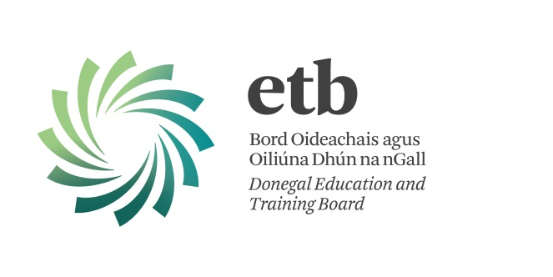




CHANGE MAKERS SEEDS OF CHANGE DEVELOPMENT Grants scheme

Reflection - Analysis - Action

DEADLINE FOR SUBMISSION: WEDNESDAY 31st JULY 2019, 1PM

Application Form
Section I - Details of Applicant Organisation

1. | Name of Group:

2. | Contact Name

3. | Address:
4. | Tel No:

5. | Mobile Telephone No.:

6. Email address
7 | Date Group Established
8 | Aims and Objectives of your Group

Section II - Project Details
.
9 | Details of Proposed project/activity:

10 | Please explain which of the UN Sustainable Development Goals your project/activity aligns to and how it is aligned (see guidelines).

11 | Target Group(s) (who will the project/activity be aimed at?):
12. | Project/Activity Duration:(estimated no. of hours and estimate start and finish date)
13. | Expected outcomes and benefits for project/activity:

14. | Estimated Numbers to be catered for: | Male | Female

15. Section III Project Cost:

 | Breakdown of Cost per course  Item | Cost
€ euro
16. | Total Estimated Cost:
 | Amount of Income towards Cost of project/activity from other sources ( Please specify source)
 | Participant Contribution if any (e.g. €20 x 8 = €160)
 | Amount of grant sought from Seeds of Change Grant Scheme

17. Bank Account Details: Please supply your Bank Account Details in order to ensure an electronic transfer of Grants:

1. | Account Name
2. | Name of Bank
3. | Address of Bank
4 | IBAN/BIC
5. | Sort Code (normally 6 digits)
6. | Account Number (normally 8 digits)

If your group does not have a bank account, please contact me to discuss.

_____________________________________________________________________

Consent for future contact regarding surveys/evaluation Y_______ N_________

Declaration:
I have read and accept the conditions outlined above and as a member of the Committee/ Group, I undertake to comply in full with the requirements of the Changemakers Seeds for Change Programme.

Signed: -------------------------------------------- Date: ___________________________

Role in Organisation: (e.g. Chairperson, secretary) ______________________________

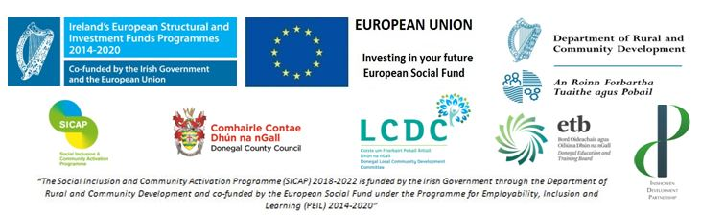
Please return completed application form to: Kate Wilkinson, Change Makers Project Coordinator, Inishowen Development Partnership, St. Mary’s Road, Buncrana, Donegal, Tel: 074 936 2218, Email: Kate@inishowen.ie

